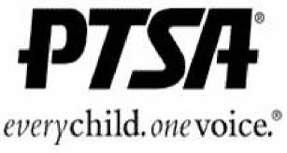
DHS STUDENTS

Need Leadership Experience?
Want to help your school and your fellow students?

Join the Damascus HS PTSA STUDENT ADVISORY BOARD

You are the “S” in our PTSA - and we need your help!

We need your opinions and your help. By joining the PTSA Student Advisory Board, you could help plan and run various projects and events at our school. You can help us determine what our PTSA should be doing to help our students and our staff.

The Student Board will meet to provide guidance and opinions to the PTSA Board to discuss the needs of Damascus students and our community, and to provide practical help to meet those needs. You will make friends, enjoy treats, and find and express your individual talents, as you serve with your fellow students in this organization.

To be on the Damascus Student Advisory Board, you must:
• Be a current PTSA member this year (2018-19)
• Be willing to attend occasional meetings
• Be reliable and committed to making a difference at Damascus

Student Name ________________________ Phone #___________________
Grade____ Student email_________________________________________
Parent Name _____________________ Best contact # __________________
Parent email _______________________________________

Your ideas how the Student Advisory Board could help our school:
____________________________________________________________________________________________________________________________________________________________________________________________________________________________________________________________________________________________________

If you have any questions, please contact PTSA President, Karen Allman, at damascusptsa@gmail.com.
Please return form via email, or send to school, ATTN: PTSA

