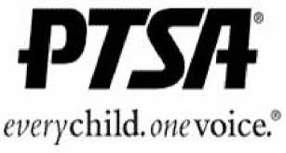
Attention: Damascus Community Businesses
Don’t miss out on this great opportunity to reach the hundreds of families who will use the:
Damascus High School PTSA
Student Directory 2017-2018

Cost: $40.00 for 1/4 page
$60.00 for 1/2 page
$100.00 for full page
$200.00 full page inside cover or back cover

Business Name:___________________________________
Ad Size: ___________________________________
Contact Name: ___________________________________
E-mail Address: __________________________________

Please return this form to: Damascus High School PTSA, 25921 Ridge Road, Damascus, MD 20872 c/o PTSA Directory no later than August 25, 2017.

Checks should be made payable to: Damascus High School PTSA
Preferred format is .jpg or.gif sent to liz.elliott@verizon.net.

Last year’s ad copy is ok to use this year – just let us know.
Please contact Liz Elliott at liz.elliott@verizon.net or (301) 651-9072

Thank you in advance for your support!

